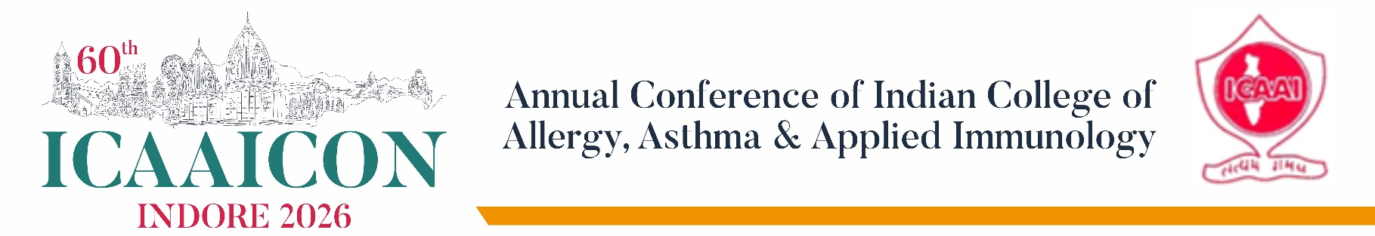
Dear Sir / Madam,
Warm greetings from the Organizing Committee.
We are delighted to invite your esteemed organization to partner with us as a sponsor and participant in the upcoming National Conference ICAAICON 2026 on Asthma, Allergy, Immunotherapy, Occupational disorders and Climate change- a focused academic event bringing together leading pulmonologists, physicians, pediatricians, Otolaryngologists, allergy specialists and Experts involved in Occupational disorders.
All these disorders are among the fastest-growing chronic conditions worldwide, with significant unmet needs in diagnosis, long-term management, and patient education. This conference is designed as a high-impact scientific platform to discuss recent advances, real-world challenges, and emerging therapies in their care.
Your organization's sponsorship will provide a unique opportunity for meaningful engagement with a targeted audience of decision-making clinicians and key opinion leaders.
Sponsorship benefits include: High-visibility brand presence among relevant specialists
- Direct interaction with clinicians actively managing asthma and allergy patients
- Opportunity to showcase products, devices, and innovations through exhibition and scientific engagement
- Association with a credible academic forum, reinforcing your company's commitment to education and patient care
We believe that collaboration between the medical fraternity and the healthcare industry is essential for improving patient outcomes, and your participation would add substantial value to the conference.
Conference Details:
Title: ICAAICON 2026
Date: 24th to 27th September 2026
Venue: Indore
We would be pleased to share customized sponsorship packages, including exhibition opportunities and branding options, based on your organization's objectives.
We sincerely hope you will consider partnering with us for this academically enriching and professionally rewarding event. We look forward to your positive response.
With warm regards,

Dr. Salil Bhargava
Chairman Organizing Committee
+91982706040 / drsalilbhargava@gmail.com

